Kulshrestha, Dhruv

TASK MANAGER

Contents

Introduction 2

Prototype Functionality 3

Background Technologies 4

Annotated Screenshots 5

Signup Page 5

Login Page 7

Forgot Password Page 9

Heuristic Evaluation and Usability Testing results 11

Heuristic Evaluation Form 12

Usability Testing Form 13

Results of HE and usability testing 14

Feedback and Discussion 20

Conclusion 22

# Introduction

In the modern day and age where technology is advancing constantly, with more and more work being done online/remotely rather than in-person, it is easy to get overwhelmed by the amount of workload since there are so many deadlines and tasks to remember, both at work and in your personal life.

More and more people are switching their approach to task management to a cheaper and convenient means which in this case could be a web-based Task manager.

A web-based Task manager/personal assistant will solve generic issues faced day-to-day such as the need to organize, prioritize and visualize work/tasks more efficiently.

Essentially, this application will be used to keep people or organisations ordered at the most fundamental level. Setting goals for tasks, charting the progress of tasks as they advance through phases of completion, and collecting analysis or reports to guide future tasks and workflows are all components of being organised.

Utilising this task manager/personal assistant system would increase production and meet deadlines and manage workload with a lot more efficiency.

For the execution of the Task manager, there are certain key user requirements that need to be met such as the following:

* User should have an easy-to-use interface that allows easy navigation and usage.
* User should be able to add, edit, delete, prioritize, and categorise tasks.
* User should be able to set due dates, receive reminders about deadlines and see if the tasks are complete, incomplete, or pending.
* User can edit, add, view, or delete their profile.
* User should be provided a secure environment by using a login system to access tasks and information, so that data is protected.
* User should be given analysis and reports that help identify patterns and make better use of their time.
* User should be provided a calendar view which displays the tasks with their deadlines.
* Users should be able to filter tasks using a filter button.
* User should be able to search their needs using a search input box.

# Prototype Functionality

Following is the list of features/functions I will be developing:

* **User account creation and login**: User account creation and login is a necessary feature for a task manager prototype, as it allows users to securely access and manage their tasks.
* **User login feature**: The user login feature is essential for users to access their account and manage their tasks securely. Without this feature, users would not be able to access their tasks and manage them.
* **Dashboard or home screen displaying an overview of tasks**: A dashboard or home screen displaying an overview of tasks is a critical feature of a task manager. It provides users with a quick and easy way to view all their tasks in one place and prioritise them.
* **Task status tracking** (e.g., to-do, in progress, completed): Task status tracking is an essential feature for a task manager as it allows users to keep track of the progress of their tasks and prioritise them accordingly.
* **Forget password feature**: A forget password feature is important for a task manager as it allows users to reset their password if they forget it. This feature ensures that users can always access their account, even if they forget their password.
* **Calendar view with task due dates displayed**: A calendar view with task due dates displayed is a useful feature as it provides users with a visual representation of their tasks and deadlines. It helps users to plan and prioritize their tasks effectively.
* **Reminders and notifications for upcoming and overdue tasks**: Reminders and notifications for upcoming and overdue tasks are essential features of a task manager. They help users to stay on top of their tasks and ensure that they do not miss any deadlines.

# Background Technologies

No external CSS frameworks or JavaScript libraries were utilized in the development of the web-based task manager prototype. Instead, a custom approach was taken, using custom CSS and vanilla JavaScript. This decision allowed for a more lightweight and tailored development process, enabling specific design and functionality requirements to be met without relying on external dependencies. By avoiding external frameworks and libraries, the development team had greater control and flexibility over the design and functionality of the prototype. While external CSS frameworks and JavaScript libraries offer convenience and pre-built components, the custom implementation ensured a more personalized and optimized solution for the task manager. This approach also minimized the overhead associated with integrating and maintaining external dependencies, resulting in a streamlined and efficient development process.

# Annotated Screenshots

## Signup Page

Similar to my previous proposed design, the following is an actual sign-page I have created, which will be used in establishing a personalized and secure online experience for website visitors. This page will allow new users who do not have an existing account, to sign up to the Task Manager and experience the full-fledged functionality available.

Login page Link

2x Password fields

Submit button

Heading

Username

Email

The following fields can be seen on the page such as:

* Email address: used as a secure means of identification since it is unique and widely used and can be used to verification.
* Username: used so that there isn’t a need for the whole email address every single time while logging in
* Password: used as a means of security and since they are unique and normally memorable to only the account owner
* Password again (This is done so that both the passwords entered are the exact same)

Another one of the links on page question ‘Already have an account?’ directs users to the login page since they already seem to have an account.

Like the login form, I have used a button for the ease of use to submit my signup form and used a tick to signify the submit button since it is a widely known symbol to confirm.

The forgot password link on the homepage allows users to reset their password in case they forget it and has been placed next to the login form and in the colour red, so it easily grabs the user’s attention.

I placed the title in the middle of the login page in a font size particularly bigger and used the font colour to be black so that there is a contrast and is easily noticeable to the user.

For the Signup Page, I have also added validation for the input fields, so they do not get left empty and without a value in the field. In case the field is left empty without a value, the following pop-up appears on the screen when the submit button is clicked.

Pop-up box

Functionality for this prototype has been simplified since when a user signs up for the Task manager, the details would already be hardcoded into the code so the submit button leads directly to the homepage. This will change since this is only to display basic functionality, as the webpage further develops, a new approach such as creating a database would be used to store the details of new users.

Also, since there are not multiple users the validation has been simplified so there cannot be any correct emails and any already existing usernames.

The Key Requirement: ‘**User should be provided a secure environment by using a login system to access tasks and information, so that data is protected.’** is satisfied by the forementioned execution of the design proposal.

I could further take this Signup-page’s quality by adding features such as Email Verification, Social Media integration, reCAPTCHA and captcha and Multi-factor authentication such as SMS.

Terms of Service could be included too.

## Login Page

Submit button

Link in case user forgets their password

Link for new users to register

Title

username and password fields in a box for user to login

By entering their details

For the Login page, I used exactly my previously proposed design with no changes and implemented it using HTML to create my page above. I have used essentially the same elements as my Signup page with some tweaks.

My login form consists of two input fields, one for the username and the other for the password which is denoted by ‘***’ in the field. It has an enter button next to it which essentially has been placed next to the fields so that the user can easily submit their form and is in green which generally denotes ‘pass’ or ‘good-to-go’.

I have used a button to submit my login form since they are easy to use, efficient and accessible for people with various sorts of disabilities.

I have also used two links; in case the user forgets their password or if they are new users which leads them to new pages. The links are in the colour red so that the user’s attention is easily grabbed, and the user can redirect themselves to help.

I will be discussing all the accessibility features that I have considered for the theme of the pages later on.

In terms of Validation, I have hardcoded a user’s details in the system so that the user can login to the system. In case either if the username or the password is incorrect or isn’t the one hardcoded into the system, a pop-up box appears on the screen like the following:

Pop-up

box

The functionality of the Login Page can be further expanded by adding features such as Social Media Integration which would make logging in even easier for the user and Also create a Database to store a user’s details and so that the information is protected and can be used for validation.

The Key Requirement: ‘**User should be provided a secure environment by using a login system to access tasks and information, so that data is protected.’** is satisfied by the forementioned execution of the design proposal.

When clicked on the ‘Signup here’ link, the Sign up page mentioned before opens up and when the ‘forgot password’ link is clicked the webpage in the next page opens up.

## Forgot Password Page

Signup page link

Login page link

Submit button

Email

Title

This page opens up which consists of one field which requires the user to enter their email address.

I have used a button to submit my login form since they are easy to use, efficient and accessible for people with various sorts of disabilities.

I have also used two links; in case the want to login or new users who want to sign up which leads them to new pages. The links are in the colour red so that the user’s attention is easily grabbed, and the user can redirect themselves to help.

In case an email is entered, the following page appears which contains a pop-up:

Pop-up box

I could further the functionality by adding a Database to store a user’s details and so that the information is protected and can be used for validation.

Also, I could use an Automated emailing system which would check the email entered in the textbox in the database and if an account exists, the email entered would automatically receive an email with a link to reset.

The Key Requirement: ‘**User should be provided a secure environment by using a login system to access tasks and information, so that data is protected.’** is satisfied by the forementioned execution of the design proposal.

In terms of accessibility for the 3 pages (Login, Signup and Forgot Password) I have discussed so far, I kept in mind the following considerations:

* **Form Structure and Labels:**

Ensures the registration form is properly structured with appropriate labels and instructions, aiding users with visual impairments who rely on screen readers.

Uses semantic HTML elements to enhance accessibility.

* **Contrast and Colour:**

Adheres to colour contrast guidelines to ensure readability for users with visual impairments.

Kept a consistent theme throughout with using the colour white and black so that the webpage looks clean and readable.

Avoided relying solely on colour to convey information, providing additional visual cues or text alternatives where necessary.

* **Keyboard Accessibility:**

Enables users to navigate and interact with the signup page using only keyboard inputs, ensuring accessibility for individuals with motor disabilities.

## Homepage

title

Navigation bar

Search bar

Settings button

Profile button

Analytics panel

Task Manager

Today’s events panel

Calendar

When the username and password inputted into the login fields is correct, the homepage shown above gets shown.

The elements my Homepage consists of with their justifications are:

* Today's Events Highlight: If any task in the list has the same date as the current day, it is highlighted under the "Today's Events" section. This helps users easily identify and focus on tasks due on the current day.
* Search Bar: The homepage provides a search bar where users can enter keywords to search for specific tasks. The search functionality filters the task list based on the entered keywords.
* Settings button: provides access to general settings, task categories or labels, reminders and notifications, collaboration settings, and data backup and sync options. The settings button allows users to fine-tune the application according to their needs, optimize productivity, and customize their task management experience.
* Profile button: The profile button in a task management application allows users to access and manage their profile information, customize preferences, adjust account settings, view user statistics, and manage integrations. It empowers users to personalize their task management experience, monitor productivity, and maintain control over their profile and application settings.
* Task Manager Panel: Users view and can create new tasks by clicking on the heading which leads to a page that provides fields to input essential details such as task name, description, due date and category. This functionality allows users to quickly capture and organize tasks. Also Tasks can be deleted.
* Title: The title in a Task Manager serves as a concise identifier and description for the page.
* Navigation Bar: navigation bar in a Task Manager application provides users with quick and convenient access to essential features and sections of the application. It typically includes buttons or links that allow users to navigate to different areas, such as tasks, projects, calendar, dashboard, and settings.
* Analytics Panel: Analytics panel is a dashboard that provides users with detailed data and insights mostly about their behaviour based on their tasks.
* Calendar preview: The calendar preview is the same as the actual calendar but consisting of no functionalities of a calendar.

For Design purposes most of the elements in my page have been narrowed down to them having simpler functionalities such as the Calendar preview, Analytics panel, Navigation bar, profile and settings buttons along with the search bar.

For the buttons, to further extend my Page’s functionality I would need to create pop-up pages with the pages consisting of several preferences and settings as to how the user would want the task manager to operate.

For the Calendar and Analytics Panel, I would have to create new pages essentially along and code it for them to work in conjunction with the task manager.

For the Search button, I would need all the functionalities of the page to be stored in a database so having a DBMS would benefit since it would make it easier to browse for what the user is looking for.

For the Navigation bar, I would obviously need all the all the pages completely developed so I could create a full-fledged bar.

For my Task manager, which is fully functional at the moment, I would consider making a database since that would make storage more secure and would allow me to store a high number of Tasks in my Task manager. Same could be said about my Today’s Events panel.

These elements fulfil the initial user requirements that were:

**“User should have an easy-to-use interface that allows easy navigation and usage”**

**“User should be able to add, edit, delete, prioritize, and categorise tasks”**

My Accessibility choices here were:

* **Keyboard Accessibility**: Ensure that all functionality within the Task Manager can be accessed and operated using keyboard-only navigation. This allows users who rely on keyboard input or assistive technologies like screen readers to interact with the application easily.
* **Focus Indication**: Provide clear visual indicators or highlights to indicate the focused element in the Task Manager. This helps users with visual impairments or those navigating through keyboard input to identify which element is currently selected.
* **Colour Contrast**: Use sufficient colour contrast between text and background elements to ensure readability for users with visual impairments. Avoid relying solely on colour to convey important information and provide alternative visual cues or labels when necessary. I used the colour red for today’s events panel so that the tasks due today can be highlighted.
* **Element/icon choice**: I used a ‘gear’ or ‘cog’ looking picture to denote it since that is the widely normalised icon for settings and be used as a clickable ‘icon’ or a button.

I made tweaks to my original design after my HE such as removing the upcoming deadlines panel since that table was a bit unnecessary for the design and my results showed that the users were not satisfied with the appearance of the homepage since it looked a bit clustered.

When The heading Tasks is clicked upon in the Table heading, The following Task Manager opens up:

## Task Manager

Button to go back to the homepage

Title

Delete button

Task name

Task category

Task description

Button to add new task

Due date

The elements in my Task Manager and their justifications are as follows:

* Title: The title allows users to provide a unique identifier or name for each task. It helps users easily differentiate between tasks and provides a brief summary or description of the task's purpose or objective.
* Task Elements:
* Task name: The task name field allows users to enter a concise and recognizable name for each task, facilitating task identification and organization.
* Task due date: The task due date field enables users to set deadlines or due dates for tasks, ensuring timely completion and helping users prioritize their work effectively.
* Task description: The task description field provides a space for users to add more detailed information, instructions, or context about the task. It helps clarify the task requirements and aids in task execution.
* Task category: The task category field allows users to assign tags, labels, or categories to tasks, providing a way to organize and filter tasks based on different criteria such as project, priority, or status. It helps users easily locate and manage tasks within specific categories.
* Add task button: The add task button allows users to quickly create new tasks. It provides a convenient and prominent way to add tasks to the Task Manager, streamlining the task creation process and ensuring efficient task management.
* Delete task button: The delete task button provides users with the ability to remove or delete tasks from the Task Manager. It allows users to clean up their task list by removing completed or irrelevant tasks, helping maintain an organized and clutter-free environment.
* Homepage button: The homepage button serves as a navigation option to return users to the main or home page of the Task Manager. It provides a convenient way to navigate back to the starting point or main dashboard, allowing users to easily access other sections or features of the Task Manager

For my Task manager, which is fully functional at the moment, I would consider making a database since that would make storage more secure and would allow me to store a high number of Tasks in my Task manager. Same could be said about my Today’s Events panel.

These elements fulfil the initial user requirements that were:

**“User should have an easy-to-use interface that allows easy navigation and usage”**

**“User should be able to add, edit, delete, prioritize, and categorise tasks”**

I used red for the delete button in a Task Manager application has several advantages. It visually signifies the potential danger of the action, grabs attention, and creates a sense of urgency.

Using blue for a "New Task" button in a Task Manager application provides visual distinction, aligns with conventions, grabs attention, and enhances accessibility.

To create a Task, this page appears to the user:

Category field

title

Submit button

Hide button

Due date field

Description field

Name field

I changed my Task Manager design appearance since using the HE the ease of access was not upto grade, so I decided to use a more interactive user friendly task manager.

The elements in my Create Task Manager page and their justifications are as follows:

* Title: The title allows users to provide a unique identifier or name for each task. It helps users easily differentiate between tasks and provides a summary or description of the task's purpose or objective.
* Hide button: The hide button provides an option for users to hide or collapse the task creation form. This can be useful when users want to focus on other tasks or elements of the page without the form taking up unnecessary space.
* Submit button: The submit button allows users to save and create the task with the provided details. It serves as the action trigger for finalizing the task creation process.
* Task Elements:
* Task name: The task name field allows users to enter a concise and recognizable name for each task, facilitating task identification and organization.
* Task due date: The task due date field enables users to set deadlines or due dates for tasks, ensuring timely completion and helping users prioritize their work effectively.
* Task description: The task description field provides a space for users to add more detailed information, instructions, or context about the task. It helps clarify the task requirements and aids in task execution.
* Task category: The task category field allows users to assign tags, labels, or categories to tasks, providing a way to organize and filter tasks based on

different criteria such as project, priority, or status. It helps users easily locate and manage tasks within specific categories.

These elements fulfil the initial user requirements that were:

**“User should have an easy-to-use interface that allows easy navigation and usage”**

**“User should be able to add, edit, delete, prioritize, and categorise tasks”**

For the Due date I decided to just use a whole calendar as the input method/format so it is easier to select dates and the user can see what day of the week it is on that specific date.

I provided clear and concise labels on the button, such as "Submit" or "Hide," further enhances its usability and understanding for all users.

For the name fields, I used Labelling by Associating each input field with a clear and descriptive label. This helps users with visual impairments or those using screen readers to understand the purpose and context of the input field.

For the Field Size and Visual Design Ensure sufficient size, spacing, and clear visual design, which would increase readability and usability of the input fields.

Let’s say a task has to be created with name ‘pickup’, category 'personal’, due date ‘today’ has to be be created it would look like the following:

And when submitted, will appear as the following:

Since The Task that has been created is due for today, The homepage updates to the following:

As it can be observed, the Task manager Table and Today’s Events updates successfully.

# 

# Heuristic Evaluation and Usability Testing results

In this section, I will be using Nielsen’s 10 Usability heuristics to evaluate My final functional high-fidelity prototype.

Nielsen’s 10 usability heuristics, are the following:

* Visibility of system status
* Match between system and the real world
* User control and freedom
* Consistency and standards
* Error prevention
* Recognition rather than recall
* Flexibility and efficiency of use
* Aesthetic and minimalist design
* Help users recognize, diagnose, and recover from errors
* Help and documentation

These heuristics will help me to identify any potential design flaws or issues based on the feedback that would be given by the end-users on the hi-fi design using the form.

## Heuristic Evaluation Form

For my Evaluation form, I essentially got some of my peers to review and feedback my hi-fi design, since my system would be useful for someone like a student, since that would help them schedule their events and exam etc.

I created an online questionnaire so that they could fill it out with ease and that way it would be easy for me to access the data and reach conclusions from it and could also view it in a graphical way.

For my HE, I got them to follow a scale to rate how well our design aligns with Nielsen's 10 Heuristics with their description, where 1 indicates poor alignment and 5 indicates strong alignment and a text box at the end of the form for any other comments.

Following is what my questionnaire that got sent to my peers looked like:

## Usability Testing Form

For my usability testing, I used a similar approach by using a google form and asking the user to perform several activities using my Task Manager Website Design.

I got my end-users to perform the several tasks:

* Task 1: Login the system with these details:

(Username: “abcd” and Password: “pass”)

* Task 2: Create a new task with a due date (3/7/23).
* Task 3: Edit an existing task and change its due date.
* Task 4: Mark a task as complete.
* Task 5: Delete a task.

I got my peers to rate the ease of completion for each task on a scale of 1-5, where 1 indicates very difficult and 5 indicates very easy.

My other form looked like the following:

## Results of HE and usability testing

For Heuristic Evaluation, I was able to collect 9 responses in order to for me to reach suitable conclusions.

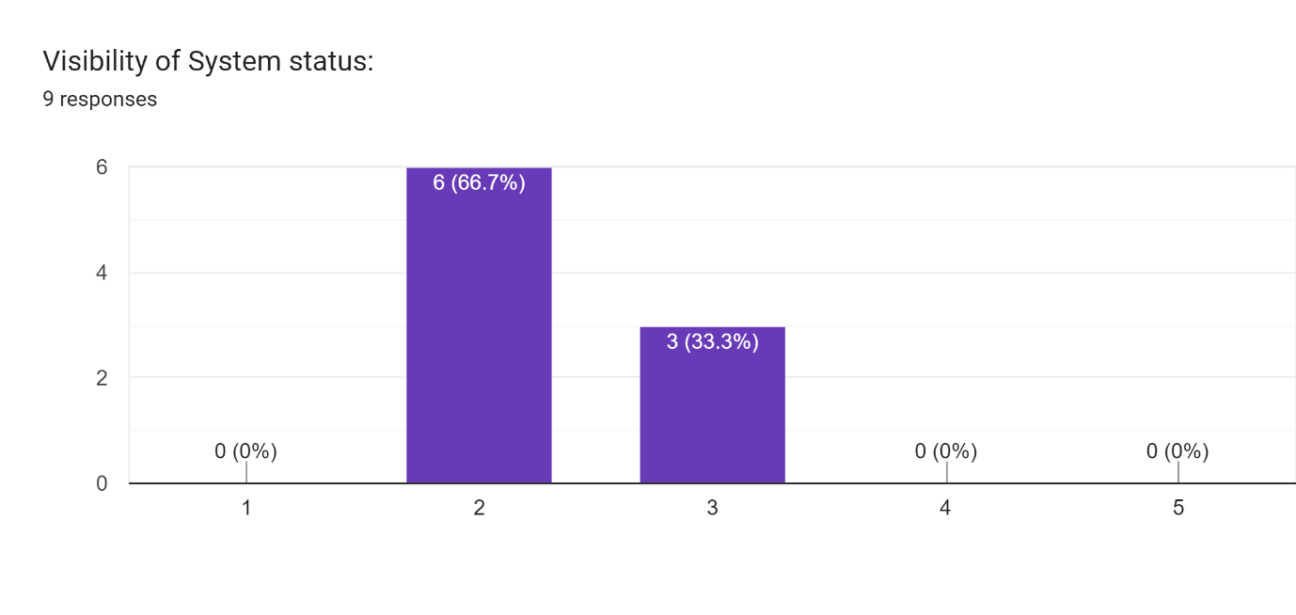

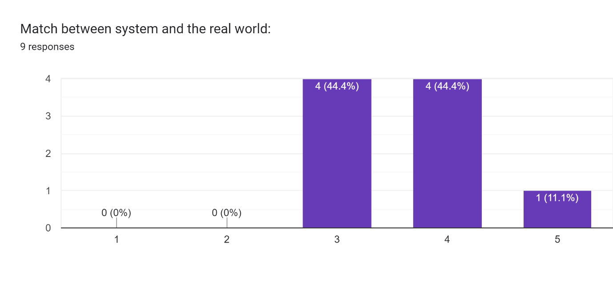

Forms response chart. Question title: User control and freedom:
. Number of responses: 9 responses. Forms response chart. Question title: Error prevention:
. Number of responses: 9 responses.

Forms response chart. Question title: Consistency and standards: 
. Number of responses: 9 responses.

Forms response chart. Question title: Recognition rather than recall:
. Number of responses: 9 responses.

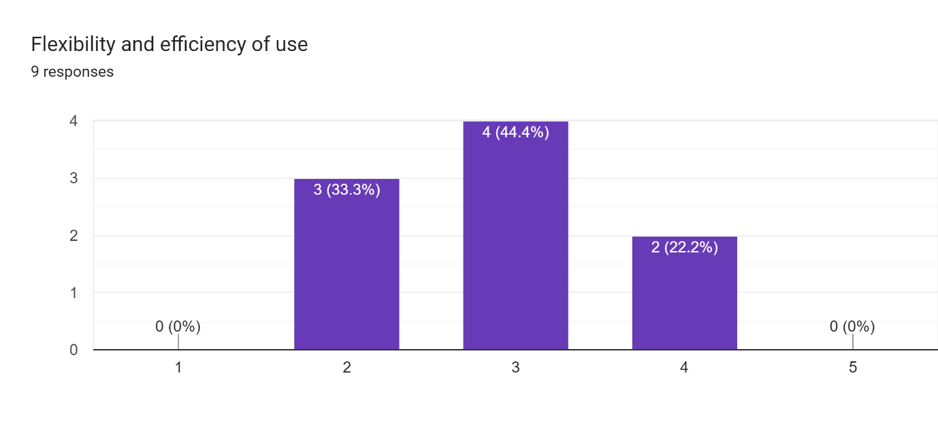

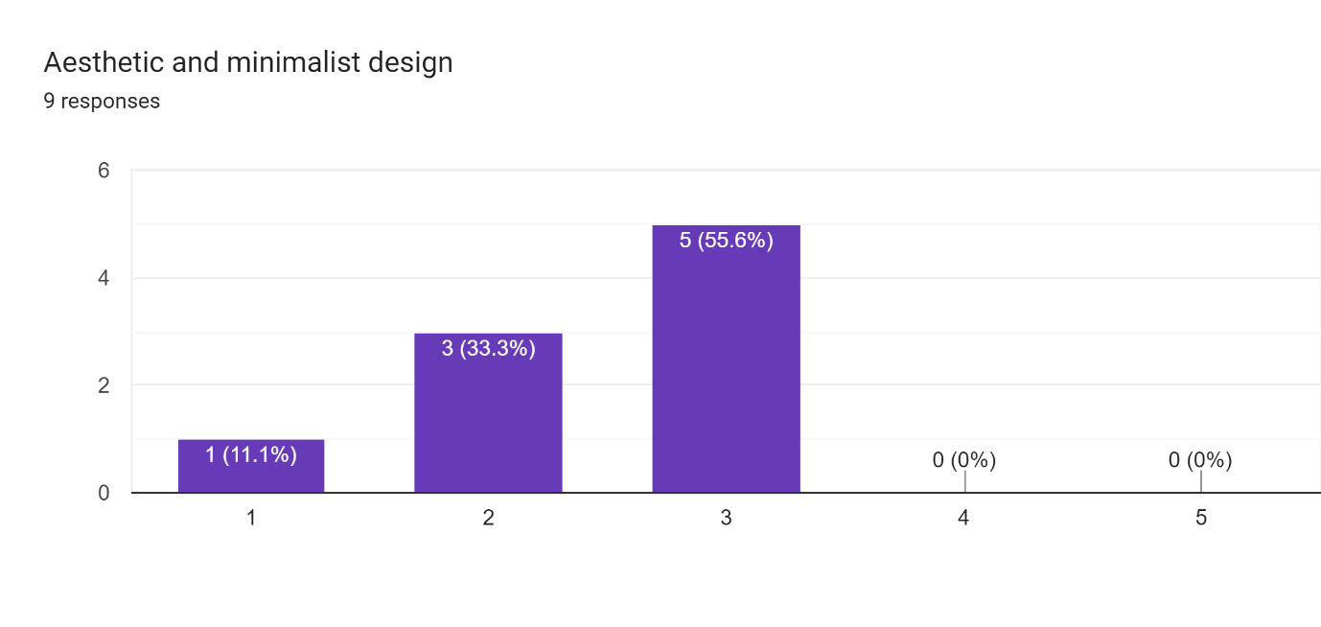

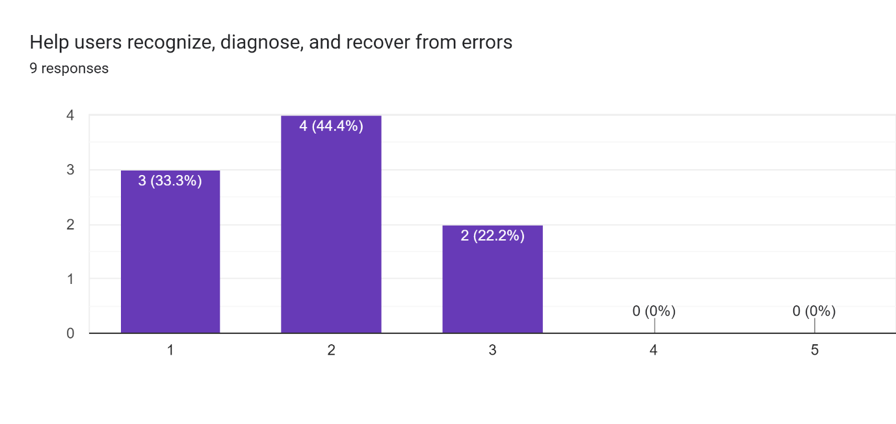

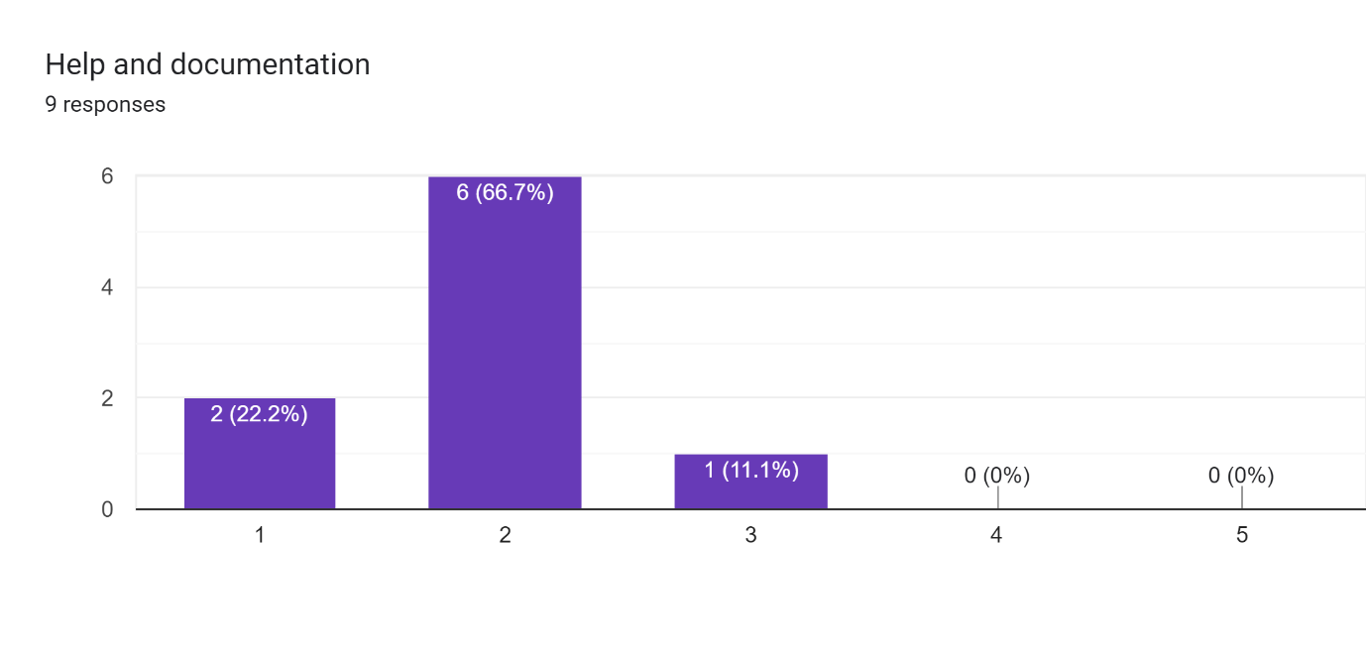

For my Usability testing, I received the following results:

Forms response chart. Question title: Task 1: Login the system with these details :

 (Username: “abcd” and Password: “pass”). Number of responses: 8 responses.

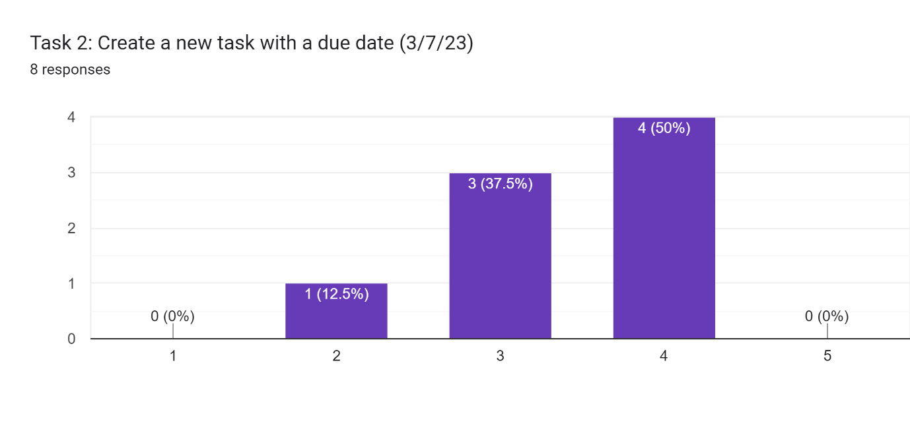

Forms response chart. Question title: Task 3: Edit an existing task and change its due date
. Number of responses: 8 responses.

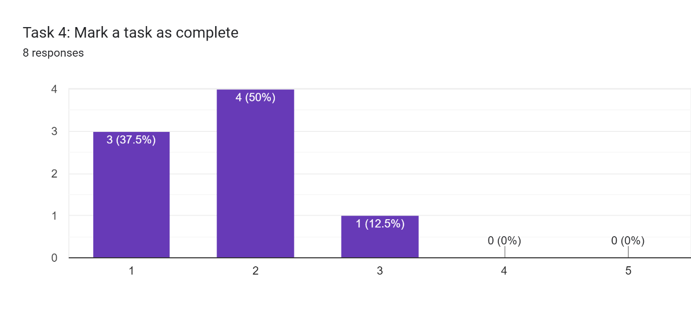

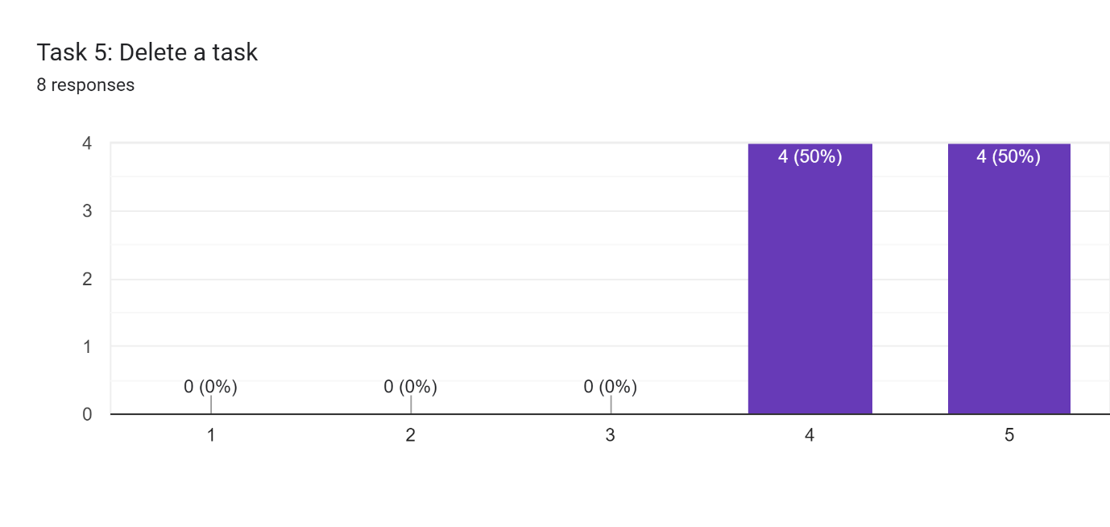

# Feedback and Discussion

In this section, I will discuss the findings from the heuristic evaluation and usability testing conducted on the Task Manager prototype. The feedback received from the participants provides valuable insights into the strengths and areas for improvement in the design. Based on this feedback, we can determine the impact on the design and justify any decisions regarding design changes or the retention of certain features.

**Heuristic Evaluation Findings:**

During the heuristic evaluation, several usability issues were identified by the evaluators. The most common issues were related to error prevention and visibility of system status. The participants found the overall design to be intuitive and user-friendly. However, they suggested the following improvements:

* Visibility of system status (Average: 2.3): Some evaluators mentioned that the system's current status, such as ongoing sync processes or pending updates, should be clearly indicated to avoid user confusion. Adding visual cues or progress indicators can improve the user's understanding of system activities.
* Match between system and the real world (Average:3.6): Not a lot of room for improvement.
* User control and freedom (Average:2.3): Provide users with more control over their actions within the task manager. Allow for easy undo and redo of actions, provide options to customize the interface, and allow users to personalize their task management experience.
* Consistency and standards (Average:3.4): Not a lot of room for improvement.
* Error prevention (Average:1.5): A few evaluators suggested adding confirmations or warnings when performing actions that have irreversible consequences, such as deleting tasks or projects. This would help users avoid accidental data loss.
* Recognition rather than recall (Average:2.9): Make it easy for users to find and access their tasks by providing clear navigation, search functionality, and categorization options. Minimize the need for users to remember specific details by providing visual cues and reminders.
* Flexibility and efficiency of use (Average:2.4): Offer customization options, shortcuts, and quick access features to cater to different user preferences and optimize task management efficiency. Allow users to streamline their workflow and access frequently used features easily.
* Aesthetic and minimalist design (Average:1.9): Maintain a clean and visually pleasing interface by using appropriate white space, consistent color schemes, and minimalistic design elements. This will help reduce distractions and focus users' attention on their tasks.
* Help users recognize, diagnose, and recover from errors (Average:1.9): Provide clear and actionable error messages that guide users on how to resolve issues. Offer relevant help resources, tooltips, or contextual assistance to assist users in recovering from errors.
* Help and documentation (Average:1.9): Include comprehensive and easily accessible help resources within the task manager, such as in-app tutorials, tooltips, and a user manual. Provide users with the necessary information to understand and effectively use the features of the task manager.

**Usability Testing Findings:**

The usability testing involved eight participants who were given tasks to perform using the Task Manager prototype. The participants provided valuable feedback regarding the functionality, user experience, and potential improvements. The following key findings emerged from the usability testing:

* Positive Feedback: The participants appreciated the clean and intuitive interface, which made it easy to navigate and manage tasks. They found the task creation and deleting functions straightforward and liked the visual representation of task status.
* Feature Expansion: Some participants suggested expanding the functionality by including features such as task prioritization, deadline reminders, and task sharing/collaboration with other users. These suggestions highlight potential enhancements to consider in the final product.
* Accessibility Considerations: The prototype was well-received in terms of accessibility. Participants mentioned that the colour contrast and font choices were legible and easy to read. However, it was suggested to include options for customizing the interface's colour scheme to accommodate individual preferences and ensure inclusivity.

**Design Impact and Justification:**

Based on the evaluation findings, certain design decisions may need to be reconsidered or retained. The feedback regarding consistency and error prevention aligns with the usability principles and should be addressed in the final product to enhance the user experience. The suggestions for expanding features will be carefully evaluated, taking into account the project scope, technical feasibility, and alignment with user requirements.

Regarding accessibility, the positive feedback indicates that the design choices made in terms of colour contrast and legibility were effective. The suggestion for customizable colour schemes will be considered to cater to diverse user preferences and ensure inclusivity.

In conclusion, the feedback and discussion section has provided valuable insights into the strengths and areas for improvement in the Task Manager prototype. The findings will influence the refinement of the design, focusing on enhancing consistency, error prevention, and system status visibility. The suggestions for feature expansion will be evaluated in terms of feasibility and alignment with the project scope. The consideration of accessibility will be further emphasized by allowing users to customize colour schemes.

# Conclusion

After examining my web-based task manager, I concluded that my reinstated design effectively satisfies the given user requirements. My Heuristic evaluation section which consists of assessing the 10 heuristics revealed some major regions for improvement and further development, but regardless of that fact, the website I have created meets the essential mandatory criteria for task management.

Areas of the task manager still require major improvements, such as improving user help and experience, optimizing the interface and so on. By making such improvements along with others, the web page will be better aligned with the given user requirements and offer a more overall effective task management system.

Even the web-based task manager needs improvement, overall, it is totally relevant to the cause and is in my opinion, a success.